SMART BLIND STICK WITH SOUND MODULE

**TEAM**

**MENTOR –** Ms.P.Vidyasri (Assistant Professor/CSE)

Vasupratha.M – (B TECH CSE-I, 2nd YEAR– RA2111003020439)

Pramikha-(B TECH CSE-I, 2nd YEAR– RA2111003020633)

Nandhini.V– (B TECH CSE-I, 2nd YEAR– RA2111003020488)

**ABSTRACT**

This paper describes the use of Arduino on ultrasonic blind walking stick. 30 million people are permanently blind and 285 billion are visually impaired, according to the WHO. When you consider them, you will realize very well that without the aid of others they can't walk to reach your destination one has to ask for directions. During their daily lives, they have to face a lot of challenges. The blind handle is safer for a person to walk. And, the human being can travel without anxiety. A blind stick is an essential tool for visually impaired individuals to navigate through their environment with greater ease and safety. With the advent of technology, blind sticks have been designed to incorporate various features that aid in mobility, including ultrasonic sensors and sound modules. In this report, we will discuss the design of a blind stick with two ultrasonic sensors and an APR33A3 sound module.

**INTRODUCTION**

The blindstick design incorporates two ultrasonic sensors that are used to detect obstacles in the user's path. Ultrasonic sensors emit high-frequency sound waves that bounce off objects and return to the sensor. The distance between the sensor and the object is calculated from the time it takes for the sound waves to return. APR33A3 sound module is used to generate audio feedback to the user. A sound module can store multiple audio files and play them when triggered. Voice feedback can alert users to the presence of obstacles such as stairs, curbs, and walls. The two ultrasonic sensors are connected to an Arduino Uno microcontroller board that processes the sensor data and sends it to the APR33A3 sound module. A sound module is connected to a small speaker that produces audio feedback to the user. When the ultrasonic sensors detect obstacles, the Arduino Uno sends a signal to his APR33A3 sound module, triggering each sensor to play a specific audio file. Audio files can be customized to provide users with specific information, such as: Distance to or direction of obstacle. A powerbank or 9v battery can be used to provide current supply to the uno board.

**HARDWARE COMPONENTS USED**

**Arduino Uno**

The Ultrasonic sensor interfacing with the microcontroller, the Arduino programming codes and the real sensor is installed on the microcontroller was part of our system. The Arduino UNO is an ATmega328p (data sheet)-centered microcontroller device. It has fourteen physical outputs and ports, six of them PMW output. It is possible to use 6 analog inputs and 16 MHz quartz crystal.

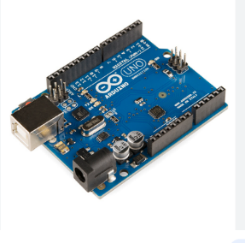

**Ultrasonic Sensor**

Ultrasonic sensors collect the data and send it in real time to the microcontroller. The microcontroller triggers the sound module after processing certain details.

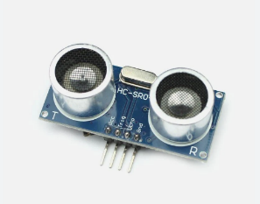

**SOUND MODULE APR33A3**

The APR33A series is specially designed for the simple key trigger. The user can record & play the message averagely for 1, 2, 4, or 8 voice message(s) by a switch and be adjusted the sample rate by using different values of resistors. It is suitable in a simple interface or needs to limit the length of a single message, e.g. toys, leave messages system, answering machine, etc.

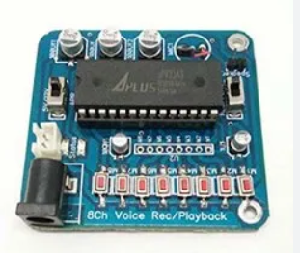

**CIRCUIT DIAGRAM**

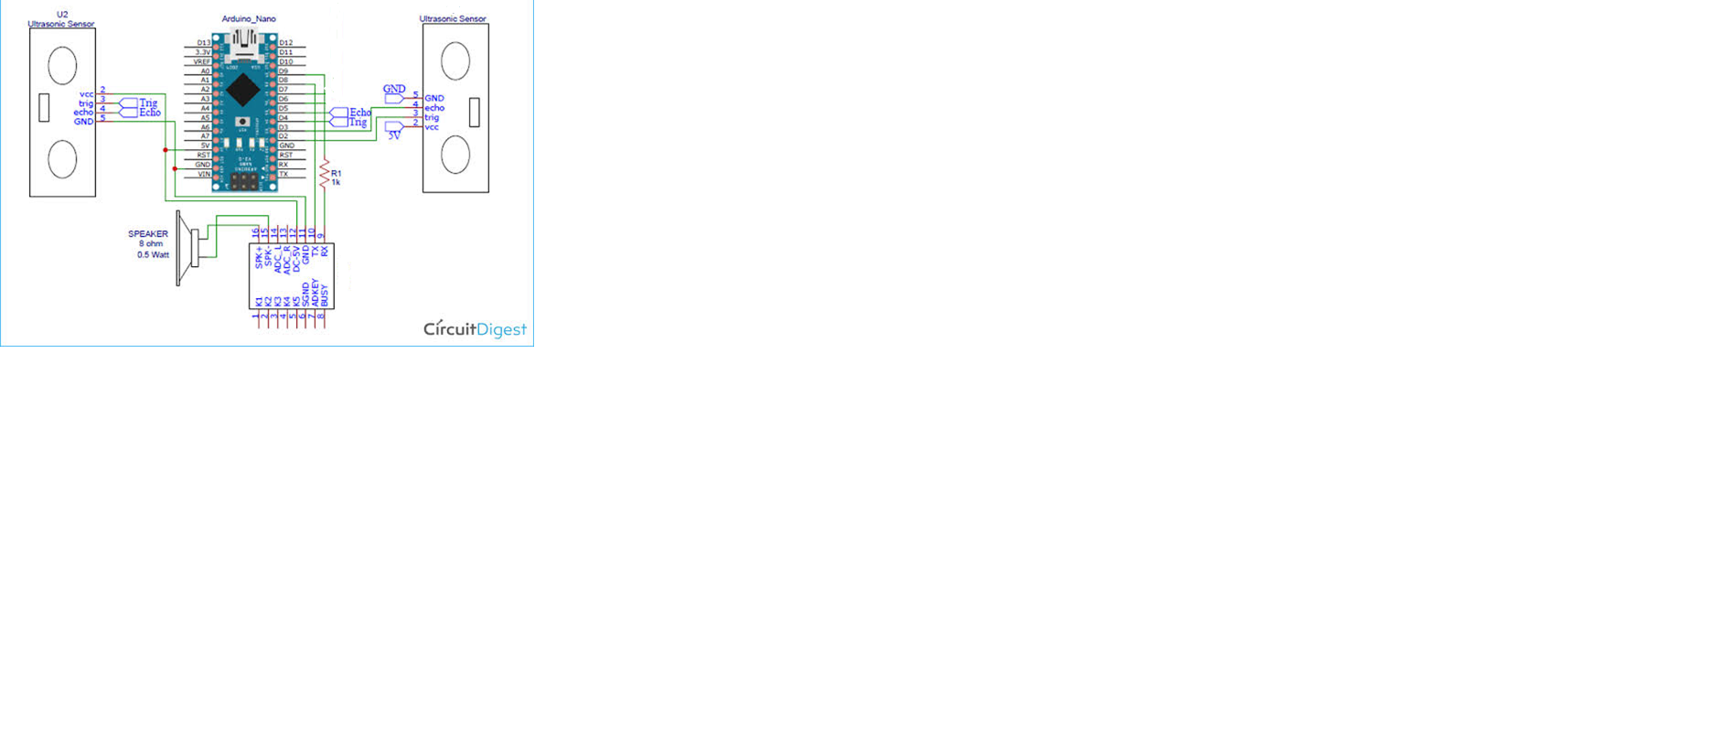

APR33A3

**Conclusion and future scope**

At this point, it should be noted that this work has been exhaustive for design and implementation movable bolt for blinds. Smart Stick serves as a versatile interface for easy and convenient work . Internal and external mobility for the visually impaired in the next phase of more assistive apps. It's a save and affordable. This enables effective obstacle detection within 3 meters in the direction of the user. It provides efficient navigation that is cost effective, reliable, lightweight, low power consumption and fast response time. Computers are wired but lightweight, with sensors and other features. Wireless connection between the components of the device improve the additional functions of this equipment and increase its range ultrasonic sensors include technology for measuring the strength of approaching obstacles. With this our target in all developing countries is specifically for the visually impaired and the blind. This analysis allows the built machine to perceive only obstacles and moisture. There can be no holes identified by the shape of this device or barrier. Ultrasonic sensor system, Arduino Uno, etc. You can develop a tool approach that uses voice commands to warn the user of the direction of travel. A vibrator can also be attached for ease of use and flexibility. Other improvements to the boost system this service will be provided in the future. These include: GPS and GSM systems to reach 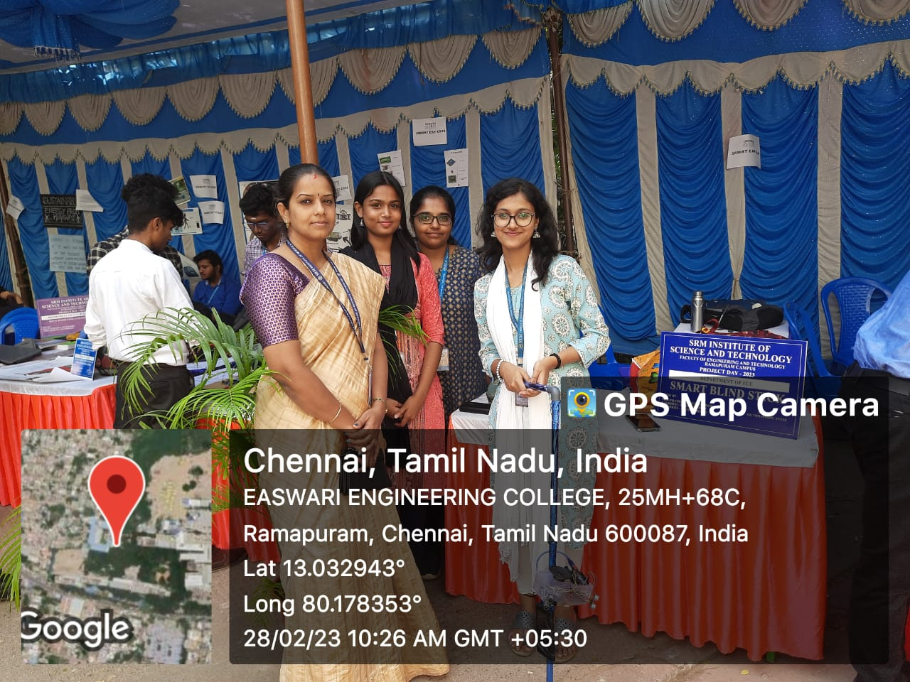parent or caregiver location should be flexible and wide of handling.